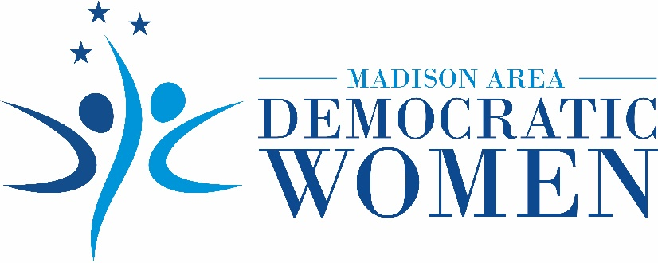

Madison Area Democratic Women Endorse Dr. Tameka Noel

for Jackson-Madison County School Board District 5
JACKSON, Tenn., July 20, 2020 – The Madison Area Democratic Women (MADW) organization announces its endorsement of Dr. Tameka Noel for Jackson-Madison County School Board District 5.

Dr. Noel is a parent and active volunteer in the Jackson-Madison County school system. She is a graduate of public schools and Duke University School of Medicine. She works as a cardiac anesthesiologist in Jackson.

“The health and safety of our children and teachers are of paramount importance while we navigate the uncertainties of the COVID-19 pandemic,” says MADW President Debbie Swacker. “As a physician and a parent, Dr. Noel has the training, knowledge and experience to meet the challenges faced by the school system during this critical time.”

“Dr. Noel is the best-qualified candidate to make important decisions about the health and education of our students, while she works diligently on behalf of teachers for the resources they need to do their job safely and effectively. Our organization enthusiastically endorses Dr. Noel for election to the school board.”

About MADW
Formed in 2017, the Madison Area Democratic Women (MADW) organization supports women and girls of West Tennessee through advocacy and education, with the knowledge that empowering women strengthens the entire community. MADW sponsors the annual Sue Shelton White Scholarship for a woman in West Tennessee who desires to restart her education.

Contact
Web site: www.madwomentn.org Email: madwomentfdw@gmail.com
Facebook: Madison Area Democratic Women of TN Phone: 731-661-1879

###

