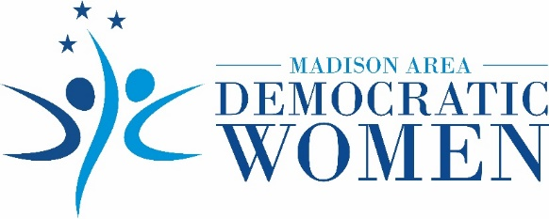

Madison Area Democratic Women Endorse Cynthia “Cindy” Boyles for

Madison County Commission District 4

JACKSON, Tenn., October 7, 2020 – The Madison Area Democratic Women (MADW) organization announces its endorsement of Cynthia “Cindy” Boyles for Madison County Commission District 4.

MADW endorses Boyles’s three-tiered plan for enhancing the lives of Madison County families:
1) improving public safety, 2) providing transparency and accessibility to county government, and
3) creating economic development opportunities by prioritizing and improving quality of life for all Madison County residents.

“I know Cindy. She has the heart of a servant and is passionate about public education, criminal justice reform, and responsible and transparent government,” says MADW President Debbie Swacker. “Cindy cares about issues affecting our community and our families. She listens to, engages with, and advocates for all people. Cindy will be a refreshing voice on behalf of Madison County families.”

“For all of these reasons,” Swacker adds, “Madison Area Democratic Women confidently and wholeheartedly urge all residents of District 4 to cast their vote for Cindy Boyles. We need her ideas, her voice, her passion, and her integrity on the Madison County Commission.”

In recognition of her service to the community, Boyles was named Person of the Year for 2019 by The Jackson Sun. She received the Jackson Area Business and Professional Women’s Sterling Award in 2020 as one of the 20 Most Influential Women in West Tennessee. Boyles received the Lane College Chapter of the NAACP Leadership Award in recognition of her work with the Jackson-Madison County Community Remembrance Project.

“I am honored to receive the endorsement of Madison Area Democratic Women,” says Boyles. “I will work with determination and compassion on behalf of all Madison County women and children. My message and my mission are clear -- let’s put Madison County families first.”

About MADW
Formed in 2017, the Madison Area Democratic Women (MADW) organization supports women and girls of West Tennessee through advocacy and education, with the knowledge that empowering women strengthens the entire community. MADW sponsors the annual Sue Shelton White Scholarship for a woman in West Tennessee who desires to restart her education.

Contact
Web site: www.madwomentn.org Email: madwomentfdw@gmail.com
Facebook: Madison Area Democratic Women of TN Phone: 731-661-1879

###

