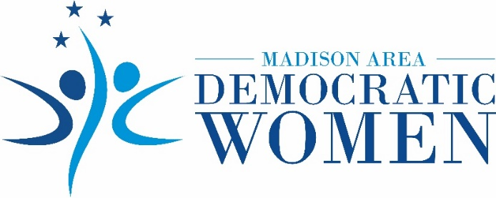
Madison Area Democratic Women Announce Video Celebrating 100 Years of Voting and Tennessee’s Role in Ratification of 19th Amendment
JACKSON, Tenn., August 10, 2020 – The Madison Area Democratic Women (MADW) organization announces the release of its new video celebrating the 100th anniversary of women winning their equal right to vote.

Rightfully Ours: The Women’s Suffrage Centennial 1920-2020 highlights Tennessee’s pivotal role in ratification of the 19th Amendment to the U.S. Constitution on August 18, 1920. The video features women and girls of West Tennessee honoring the women of the past who fought for the right of women today to have a voice and cast their votes.

Featuring multiple generations of women, the video closes with a reading of the 19th Amendment by Stephanie Turnbow of Union City and her grandmother, Patsy. Ms. Turnbow was awarded the inaugural Sue Shelton White Scholarship in March by Madison Area Democratic Women. She is a mother of three and returning to college with the goal of opening her own business and inspiring other women to do the same. Ms. Turnbow stated, “The Sue Shelton White Scholarship will help me to honor my grandmother’s legacy of strength and independence.”

Rightfully Ours: The Women’s Suffrage Centennial 1920-2020 was produced by Majure Works, a multimedia and business consulting company (majureworks.com).

To watch the global premiere of this compelling video, go to Madison Area Democratic Women’s website at http://www.madwomentn.org/ or watch on YouTube at https://youtu.be/Uc7QcrzbNVg

About MADW
Formed in 2017, the Madison Area Democratic Women (MADW) organization supports women and girls of West Tennessee through advocacy and education, with the knowledge that empowering women strengthens the entire community. MADW sponsors the annual Sue Shelton White Scholarship for a woman in West Tennessee who desires to restart her education. MADW is a member of the Tennessee Federation of Democratic Women.

Contact
Website: www.madwomentn.org
Facebook: Madison Area Democratic Women of TN
Email: madwomentfdw@gmail.com
Phone: 731-661-1879
###

